Technical Datasheet WIN-SN-TnH-W-D Sensor
The Master Display Unit serves as a central hub that wirelessly receives temperature and humidity data from a connected slave sensor over a local Wi-Fi network. Once the information is received, the Display Unit collects and displays the environmental data directly on the screen. To enhance on-site monitoring, the interface features onboard data logging and plots real-time visual graphs for both temperature and humidity.

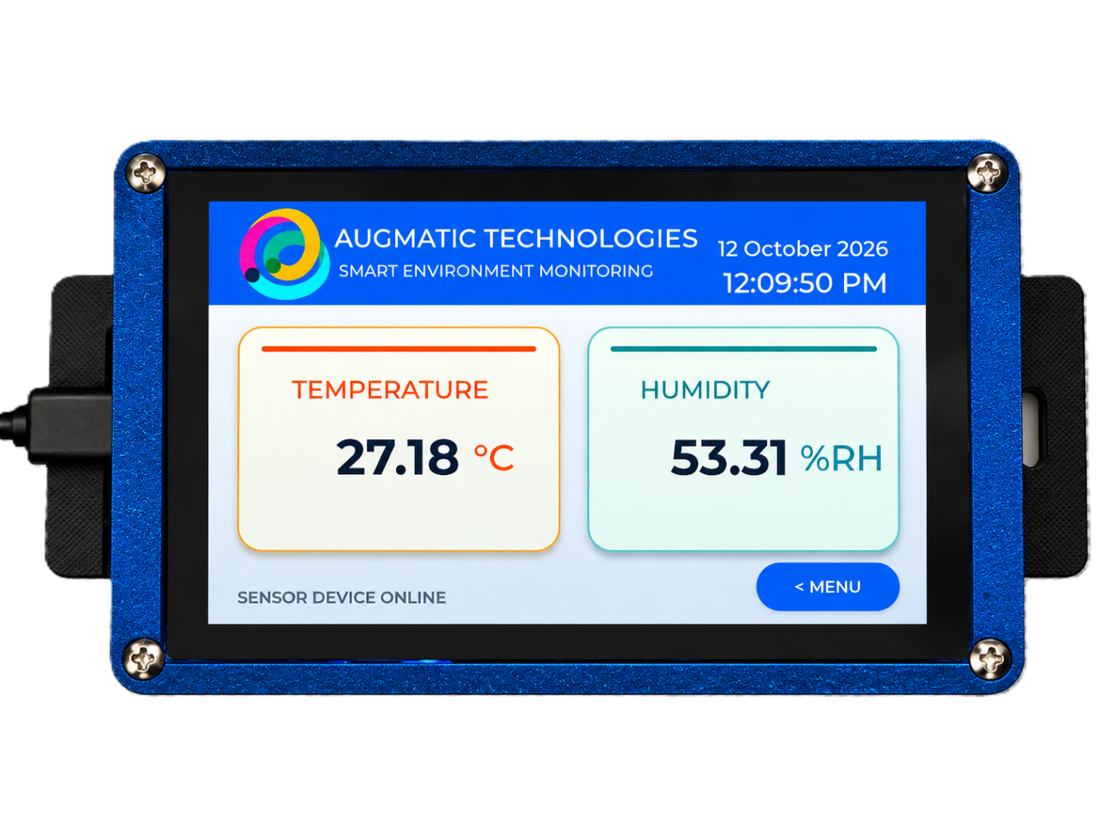
Display Module: -
The module features a wall-mountable enclosure with an integrated display for easy installation and deployment. The unit is designed for continuous 24/7 operation and is exceptionally easy to use.
For seamless setup, configuration settings such as local Wi-Fi connectivity and sensor pairing can be managed directly through the integrated display interface or the built-in web portal.

Specifications
General –
Dimensions 98 mm L x 98 mm B x 34 mm H
Power Input Power – 5 VDC Type C
Operating Temperature -20°C to +80°C (-4°F to +176°F)
Storage temperature -20°C to +80°C (-4°F to +176°F)

Storage Humidity 5 ~ 95 % RH, non – Condensing
Certifications

Operator Interface & Navigation Guide

1. Initial Network Provisioning (Wi-Fi Setup):
Upon first boot or when a network change is required—the device enters Access Point (AP) mode, and the screen displays a "WiFi Setup Required". The unit broadcasts its own local network named WIN-SN-TnH-W-M-D-5.0. Users simply connect to this network via a mobile device or laptop using the password 12345678. Open a web browser and navigate to http://192.168.4.1 to securely pass your local Wi-Fi credentials to the unit.
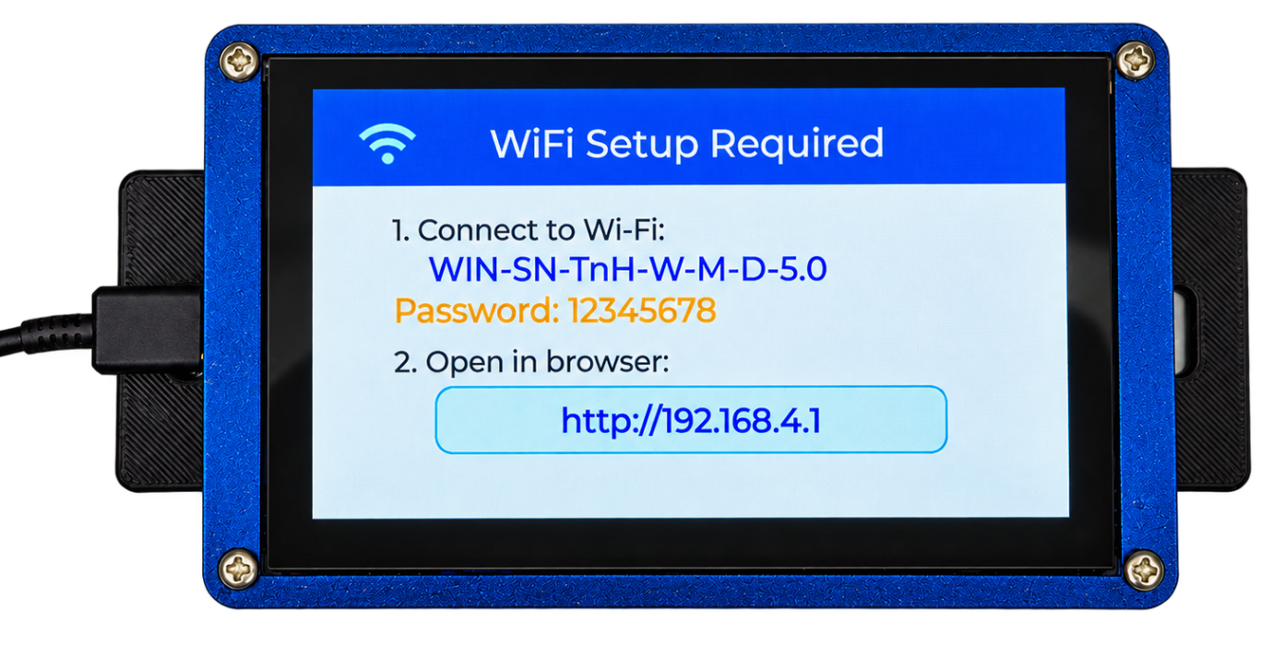

2. Home Screen & Main Navigation
Once provisioned, the device boots to the Home Screen, displaying the company logo (WittelB), the current date and time, and the system title ("Augmatic Technologies - Smart Environment Monitoring"). Tapping the orange [ NEXT > ] button at the bottom right opens the Main Menu, which splits the interface into three primary pathways:
- Dashboard: View live temperature and humidity data from the connected sensor.
- Local Trends: Displays historical trend graphs for each monitored parameter (Temperature & Humidity). Users can independently select 6-hour, 12-hour, or 24-hour trend data for each parameter.
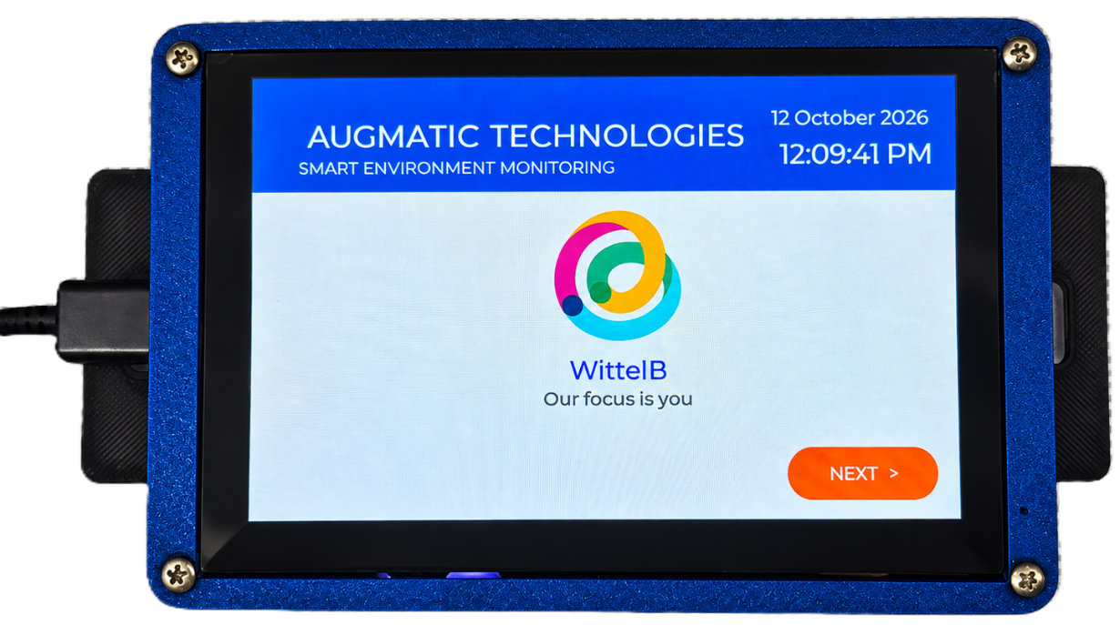
- WiFi Settings: Access network and sensor configuration parameters to update the device whenever the Wi-Fi network changes.
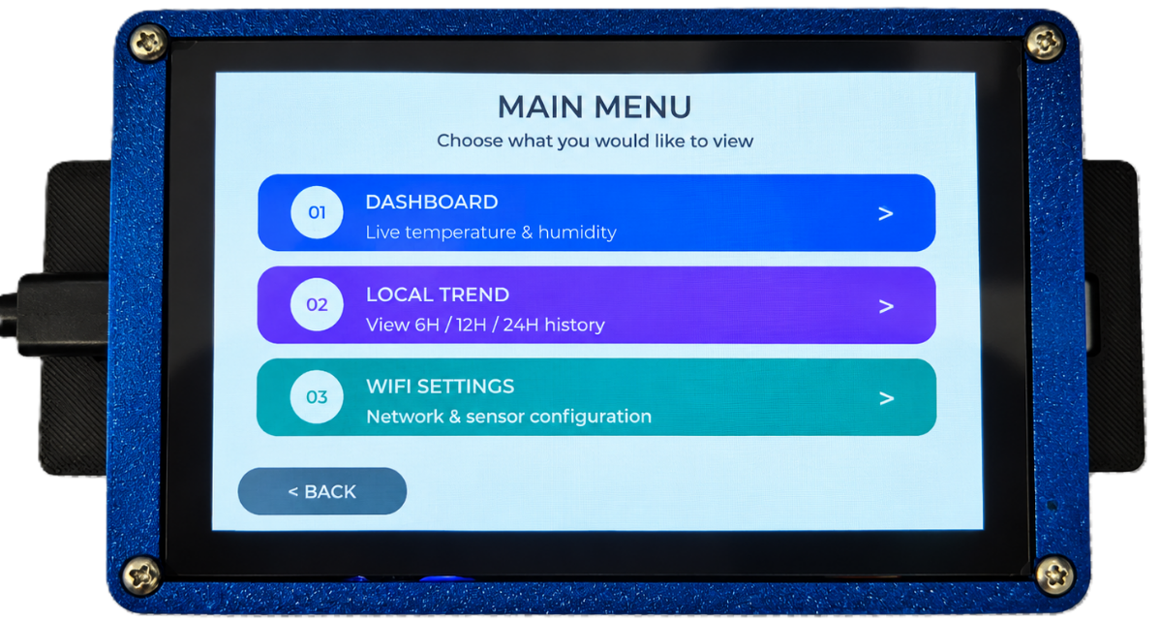

3. Live Telenett Dashboard / Live Telemetry Dashboard
The Dashboard provides a clear, real-time view of all monitored parameters on a single screen, enabling users to quickly assess current environmental conditions.
- Real-Time Monitoring: Displays the latest values of all connected sensors, including Temperature & Humidity
- Color-Coded Display: Each parameter is presented in a dedicated color-coded tile for improved readability and quick identification.
- Instant Data Updates: Sensor readings are refreshed continuously, providing up-to-date information for effective environmental monitoring.
- User-Friendly Interface: The intuitive display allows users to easily view and monitor all air quality parameters from a single dashboard screen.

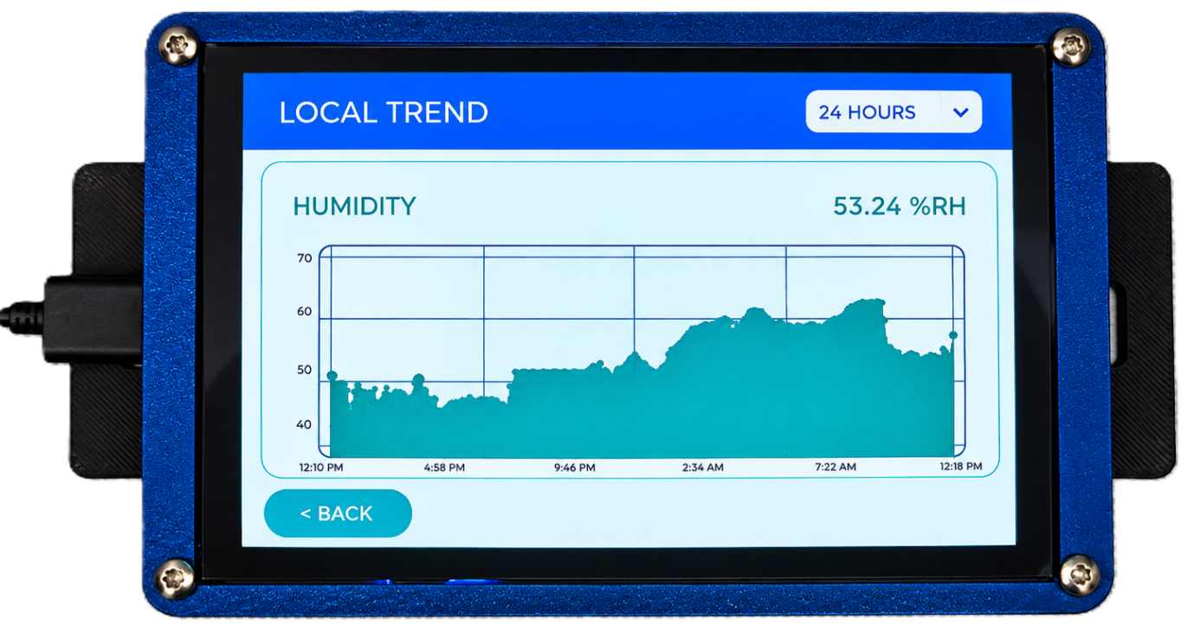
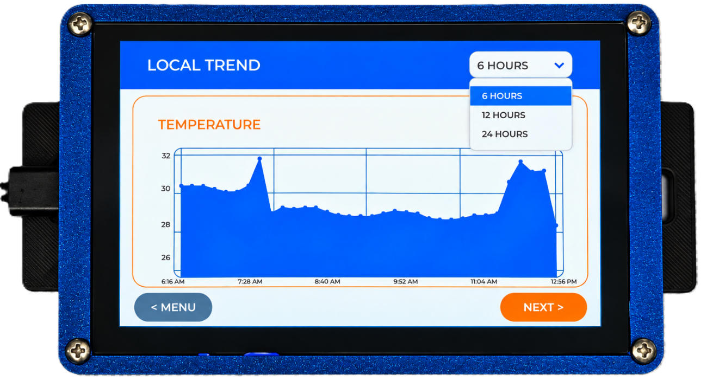
4. Local Trends

- Live Trend Monitoring: View real-time graphical data for Temperature & Humidity, enabling continuous monitoring of environmental conditions.
- Individual Parameter Analysis: Each parameter (Temperature & Humidity) can be viewed independently with its own dedicated trend graph.
- Selectable Time Range: Users can choose 6-hour, 12-hour, or 24-hour historical data for each parameter individually to analyze short-term and long-term trends.
- Default Time Range: By default, the trend graph displays the last 6 hours of data. Users can change the view to 12 hours or 24 hours for each parameter individually.

Web Portal Configuration Guide

The embedded web portal provides a unified, single-page interface for configuring both local Wi-Fi credentials and sensor IP addressing. This streamlines setup and enables seamless remote sensor data monitoring.
  - Initial Wi-Fi Connection & IP Setup
- First, connect your mobile device or PC directly to the Display's local hotspot. Search for the Wi-Fi network named WIN-SN-TnH-W-M-D-5.0 and enter the password 12345678.
- Open your web browser and navigate to 192.168.4.1 to access the initial configuration portal.
- Enter your local Wi-Fi network credentials to connect the device to your facility's network.
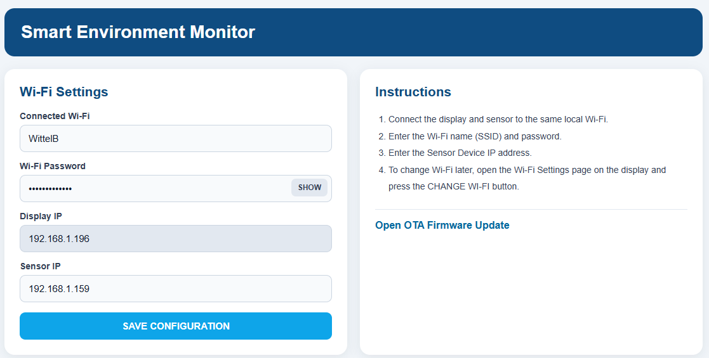

  - Accessing the Smart Environment Monitor Settings
- Ensure your PC or mobile device is now connected to your standard local network (the same one the device just joined).
- Enter the assigned IP Address (e.g., 192.168.1.196) into your web browser. (Note: You can locate the correct Sensor IP Address by checking the Slave Device's Wi-Fi Configuration web page).
- You will be directed immediately to the unified Smart Environment Monitor Configuration Settings page.

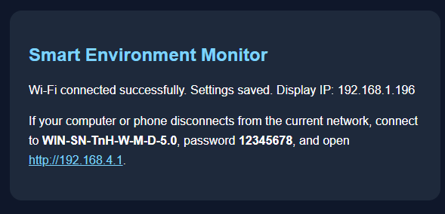

Contact us: -
Augmatic Technologies Pvt. Ltd.,
Plot no 6, Shah Industrial Estate II,
Kotambi,
Vadodara – 391510.
Email – Sales@wittelb.com
Support: support@wittelb.raiseaticket.com / +91 94038 92805

